Supplementary Information S1 : Curated image bank
The large volume of images available in the DIAMS database makes it impossible to process them all exhaustively. It is therefore necessary to extract a relevant subset that is representative of the conditions throughout the entire period covered, while maintaining sufficient quality in terms of data completeness. The document describes the approach taken to achieve this selection.

Hour filtering
Only images captured at midnight and noon are selected. These schedules are retained because they represent night and day periods respectively, regardless of seasonality.

Completion of the dataset
In order to assess the completeness of the data, a comprehensive grid of all possible combinations (day, time, position, depth, orientation) is generated. This is then cross-referenced with the observed data in order to identify any missing combinations.
Visualisation of filtered data :
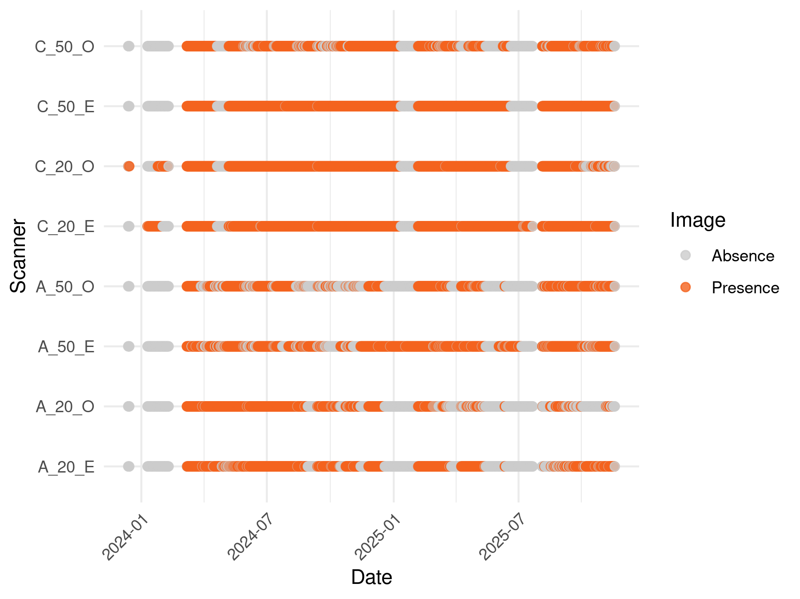
Figure 1: Presence/absence of images by scanner and date

Period selection
To guarantee the quality of the selected subset, data completeness is verified for each acquisition date and over continuous periods.
First, the expected number of images per day is determined :
Number of images expected per day : 16
We then identify the days on which at least 65% of these images are present :
Number of images expected per day : 10
We select the groups of 7 consecutive days that meet this criterion :
Viewing filtered data:
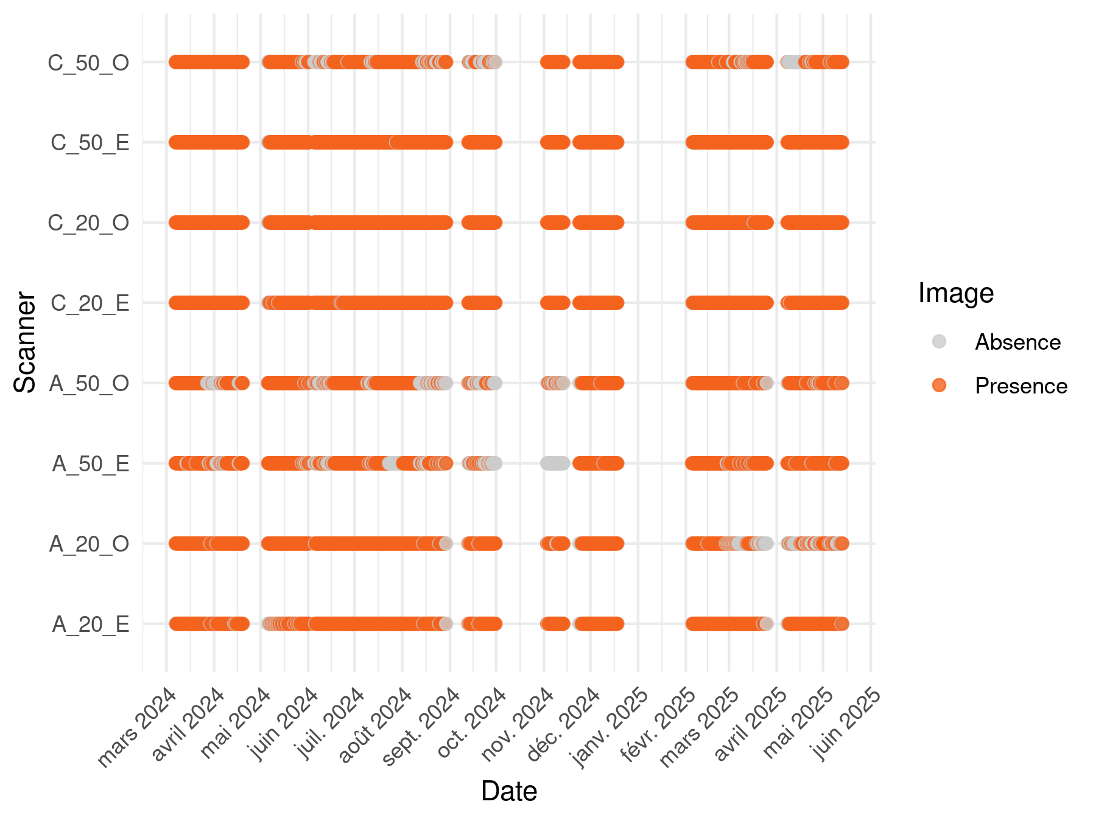
Figure 2: Presence/absence of images by scanner and date

Selection of representative weeks
In order to cover different seasonal and crop phases, several 7-day periods spread throughout the year are targeted.
Five target dates, spread throughout the year, are selected as the starting point for each 7-day period. For each date, the following 7 days are retrieved from the filtered data. Days with at least 90% of the expected images are counted. A week is considered “complete” if all 7 days are valid.
# A tibble: 7 × 3
period valid_days complet
<int> <int> <lgl>
1 1 7 TRUE
2 2 7 TRUE
3 3 7 TRUE
4 4 7 TRUE
5 5 7 TRUE
6 6 7 TRUE
7 7 7 TRUE
Each period is associated with a crop and a season according to its dates, by cross-referencing sowing/harvesting periods and calendar definitions of seasons.
Summary of selected periods:
Table 1: Summary of selected periods
Period | Start Date | Final Date | No. Images | Crops | Seasons
1 | 2024-03-20 | 2024-03-26 | 111 | wheat | winter, spring
2 | 2024-05-25 | 2024-05-31 | 100 | wheat | spring
3 | 2024-07-15 | 2024-07-21 | 111 | sorghum | summer
4 | 2024-09-19 | 2024-09-25 | 82 | sorghum | summer, autumn
5 | 2024-12-10 | 2024-12-16 | 112 | Bare soil | autumn
6 | 2025-02-15 | 2025-02-21 | 111 | Bare soil | winter
7 | 2025-04-20 | 2025-04-26 | 98 | Chickpea | spring
Final display of selected periods
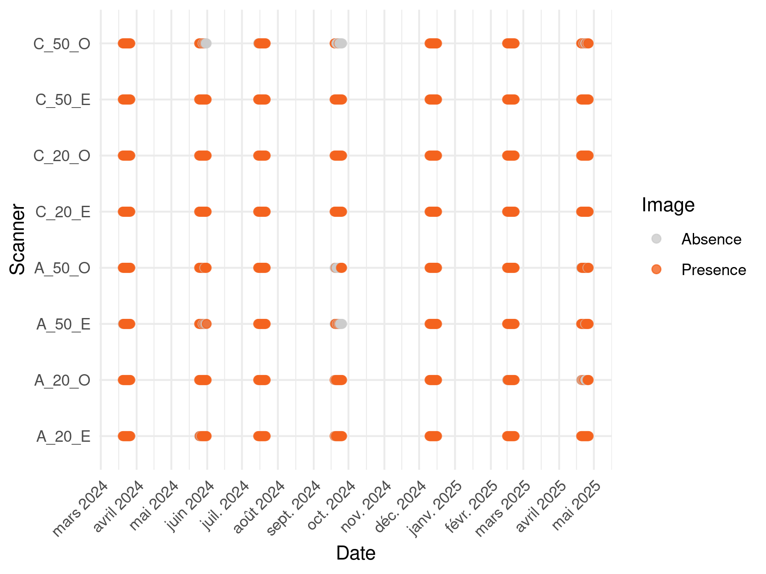
Figure 3: Presence/absence of images by scanner and date

Selection of previous images for differentiation
Creation of a copy of the image set with dates shifted by 9 days and selection of corresponding images
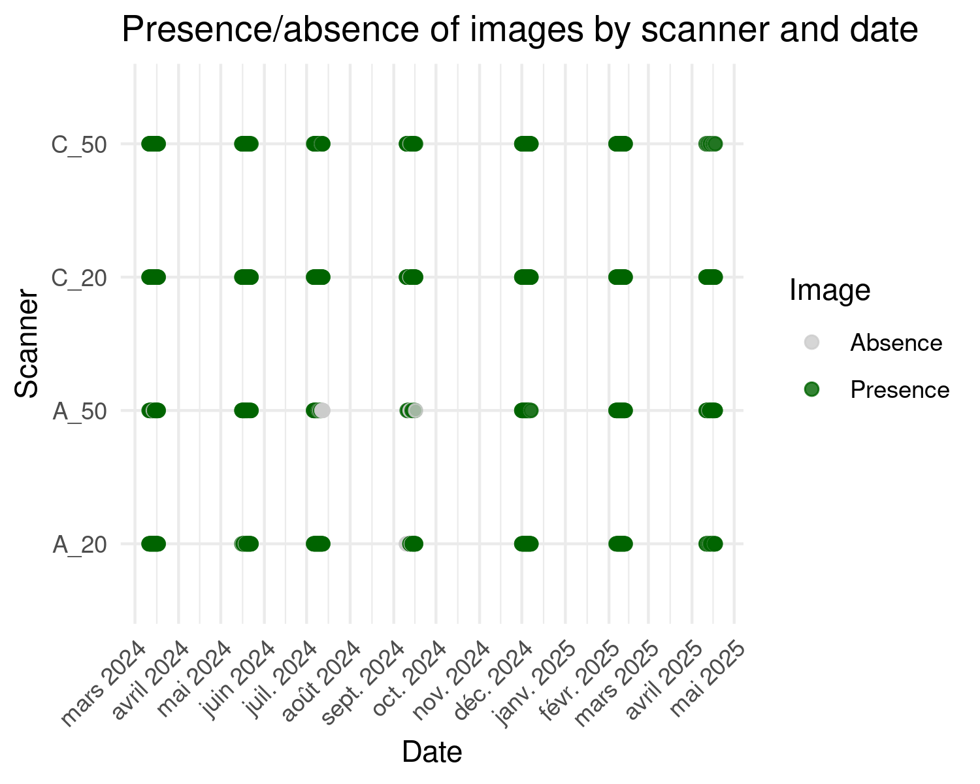
Figure 4: Presence/absence of images by scanner and date
Filtering images from the current dataset based on missing images from the previous dataset
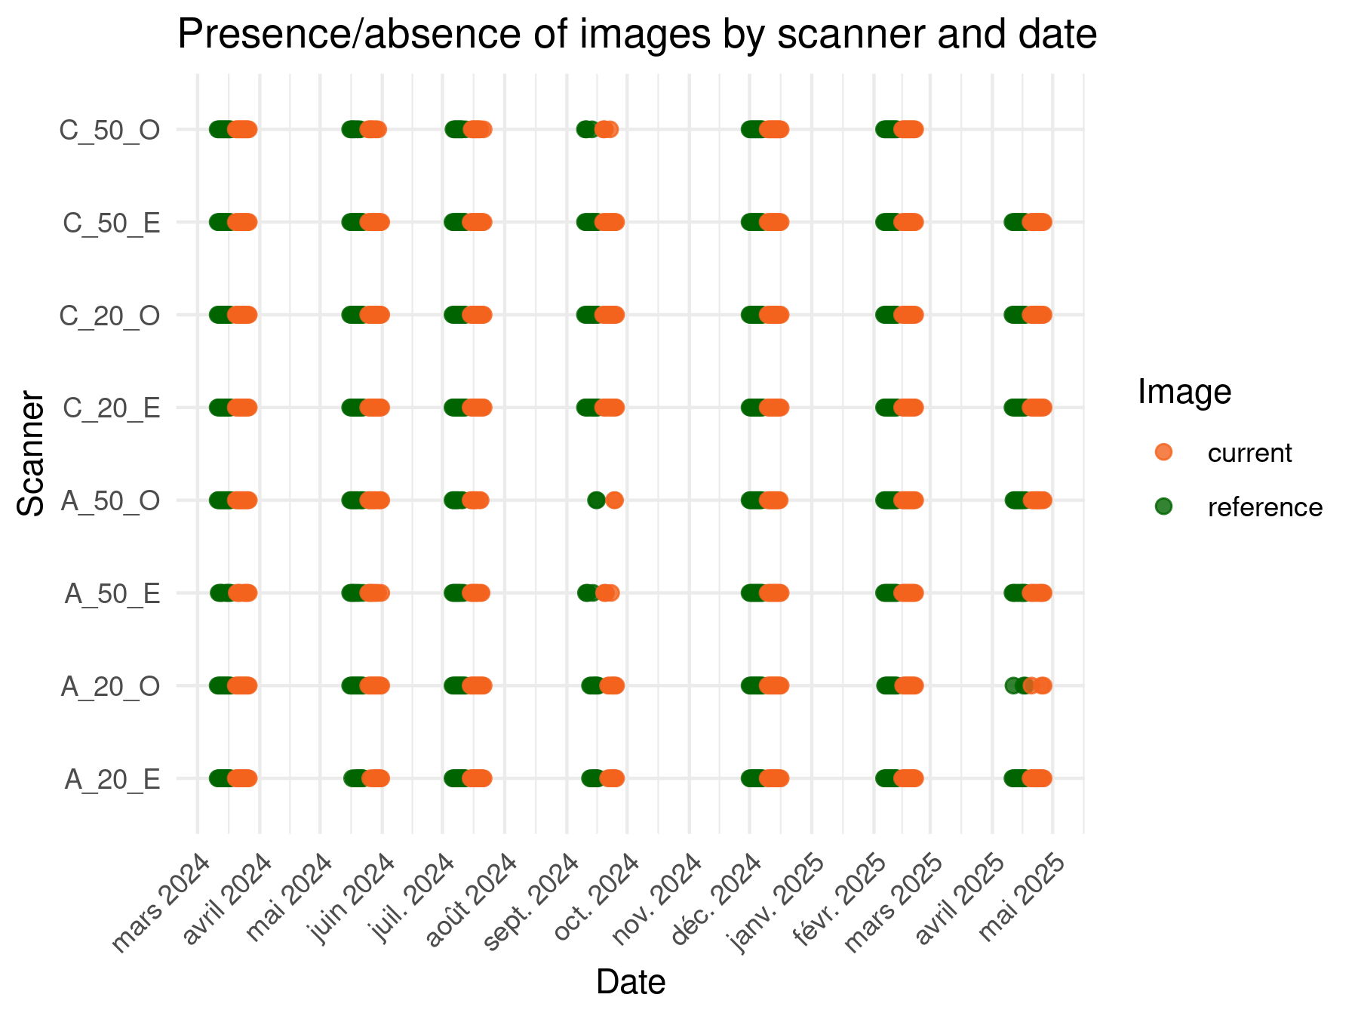
Figure 5: Presence/absence of images by scanner and date
--- FINAL COMPLETENESS REPORT ---
Initial target images (T0): 784
Analyzable pairs (T0 + T-9): 678
Number of missing images : 106
Missing frame rate : 13.52 %
Dataset Characterization
Dataset Name | Description | Role in the pipeline
df_complete | Theoretical grid vs. Observed data. | Used to calculate the initial missing data rate and identify stable periods.
df_final | Targeted images based on seasonal periods. | Represents the “intended” scope of the study.
df_reference | Set of images shifted by -9 days. | Acts as the baseline (J-9) for every observation.
df_final_filtered | Images from df_final that passed the J-9 check. | These are the “Current” images that are actually treatable.
df_combined | Union of df_final_filtered and their valid references. | The final list of all unique image names required from the server.

Generalized Diagnostic Function
==========================================
INTEGRITY REPORT: root_mask_data
==========================================
Expected Unique IDs: 1356
Actual Unique Found: 1356
Coverage Rate: 100 %
SUCCESS: No missing data.
==========================================
INTEGRITY REPORT: output_raster
==========================================
Expected Unique IDs: 678
Actual Unique Found: 678
Coverage Rate: 100 %
SUCCESS: No missing data.
==========================================
INTEGRITY REPORT: distance_habitat_data.csv
==========================================
Expected Unique IDs: 678
Actual Unique Found: 665
Coverage Rate: 98.08 %
MISSING DATA ( 13 items):
[1] "AF_A20_E_2024-07-20_12H00M" "AF_A20_O_2024-12-12_12H00M"
[3] "AF_A50_E_2024-07-19_00H00M" "AF_A50_E_2024-07-20_00H00M"
[5] "AF_A50_E_2025-04-22_12H01M" "AF_A50_E_2025-04-25_12H00M"
[7] "AF_A50_E_2025-04-26_12H00M" "AF_C20_E_2025-02-20_12H00M"
[9] "AF_C20_E_2025-04-24_12H00M" "AF_C50_E_2024-07-17_12H00M"
==========================================
INTEGRITY REPORT: distance_data_cleaned.csv
==========================================
Expected Unique IDs: 678
Actual Unique Found: 616
Coverage Rate: 90.86 %
MISSING DATA ( 62 items):
[1] "AF_A20_E_2024-07-20_12H00M" "AF_A20_E_2024-12-15_12H00M"
[3] "AF_A20_E_2024-12-16_00H00M" "AF_A20_E_2025-04-25_00H00M"
[5] "AF_A20_O_2024-05-29_12H01M" "AF_A20_O_2024-05-30_00H00M"
[7] "AF_A20_O_2024-05-30_12H00M" "AF_A20_O_2024-07-15_00H01M"
[9] "AF_A20_O_2024-07-15_12H00M" "AF_A20_O_2024-07-16_00H00M"

